Step by step guide for Interview preparation and placement

Step 1 Prepare your introduction

First I would like to thank you for giving me this opportunity to introduce myself. I am ……………… from Delhi
(Name of city you belong). My qualification is……………………. and currently I am pursuing Travel and Tourism
Diploma Course from The Tourism School.
In this course I have gained practical knowledge of real work of Travel Agencies. In my course I have learned
everything by doing it in reality like the work happens in Travel Companies, so I have got the qualification &
work experience both. (Here you elaborate about the other topics and practical work you have learned) I am
confident about using MS office functions in day to day operations.
Coming to my family background, my father is (tell about profession of your father) and my mother is home
maker (If she is also doing some work or job then tells about that). After this you can mention about your
siblings (brothers & sisters). I want to make my career in Travel &Tourism industry & I hope I can start a
bright career from your esteemed organization.

Step 2: Practice your introduction in front of mirror 3 to 5 times a day

Step 3: Prepare your resume & Submit

Example of CV format of the resume given on page 10. Once resume is ready, send in word format on
faculty@TheTourismSchool.com Our process of sending your resume for interviews will not start without
getting your resume by email and till you won’t post your resume on Naukri.com, if your resume is already
posted then update it and mention about the course you are doing. If you need help in posting the resume
on Naukri.com then please do fix meeting with us and you will get all the assistance.

Step 4: Post your resume on Naukri.com How to do file provided on page 3

Step 5: Interview Preparation- Most commonly asked questions & their suggested answers are given
below:

Q1. What did you learn in this course?
A1.Answer is same as mentioned in the introduction about your course.

Q2.Why did you opt for travel and tourism course/career in this industry?
A2.I was always very interested in knowing about different places of the world, attractions of the world. I got a chance to do “Travel and Tourism Foundation Diploma” from The Tourism School. Tourism School taught me everything related to travel industry in a very practical manner which made me confident in making packages, creating PNR, designing itineraries, issuing hotel vouchers, etc.

Q3. What are your short term goals?
A3.I want to be working for an excellent organization like yours in which I am managing operations of your travel agency. I plan to contribute my, ticketing, itinerary designing, destination knowledge learnt in the course.

Q4. What are your strengths and weaknesses?
A4. I am a proactive, focused, punctual person.
Coming to my weaknesses, I feel a sense of urgency in completing the task. I am workalcohlic.

Q5. What are your salary expectations?
A5. I’m fresher, foremost thing is to improve my skills and knowledge in the Corporate world. And I am expecting salary to fulfill my economical needs.

Step 6: Practice questions in front of the mirror with friends At least 3 - 5 times in a day

Step 7: Inform tourism school by email and is when ready for interviews
Send an email to us stating you are ready to face the interviews available for interviews from tomorrow onwards, write email at Faculty@TheTourismSchool.com

Step 8: Tourism School's process for interviews
- You will get email from Tourism School with an interview schedule a day before the interview. You must
- check your email twice in a day, first around 9 AM and second time check at 5 PM
- It is mandatory for a student to acknowledge the mail on the same day. In case we do not receive acknowledgement mail from your side, you will not be informed for interview ever again.
- Once your interview is over, you need to send us a notification email. Inform us how your interview was the same day and that you can do by calling us also.
- We will inform you of your interview result within 3 working days
- If you don’t succeed in that particular interview then within 7 to 10 working days you will get another call, you have to follow the same process for each interview call and after giving the interview.
- We will keep providing you interviews till you won’t get the job.

Step 9: Preparation for the interview
- Research the company's website
- Practice your introduction
- Proof read your resume
- Keep your file ready, keep 5 copies of resume, pen, and 2 passport size photograph

Interview day
- Dress formally
Men – Wear a business suit with light color shirt, nice tie and polished shoes. Be clean shaved and haircut should be proper.
Women – Wear a business suit with a light color shirt or a nice light color cotton salwar suit & a nice pair of heels. Tie your hair or keep it lose in a nice manner
Example photographs of formal dressing given on page 9
- Reach 20 mins before the time.
- Turn your cell phone off or on silent mode before you walk into the interview room.
- Be confident, honest in answering your questions. Keep your statements simple and short. Look in the eyes of interviewer
- Thank the interviewer once interview is over.

Step 10 : After the interview
- Send us a notification email once your interview is over or inform by phone call or you can send SMS on 8882888309.
- In case you get a call for selection, do notify us for the same via phone or email
- If you decide not to join any particular job or company then also you can inform us and we will respect your decision and will not force you
How to post your resume on www.naukri.com

Process Note
Step 1: Enter email id and password and click on register

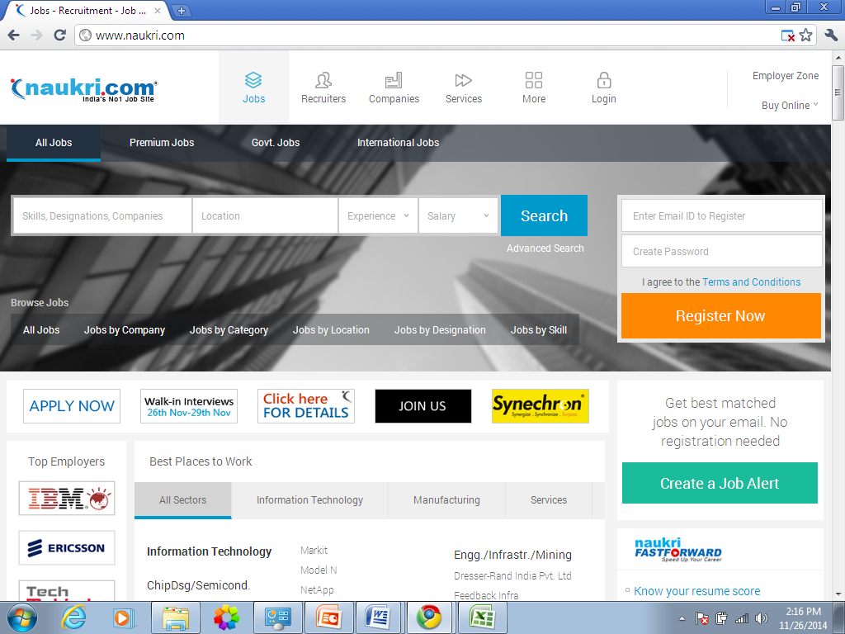

Step 2: Fill all the required details to complete your profile. It is important to maintain profile completeness more than 90% to increase the chances of calls from recruiters.

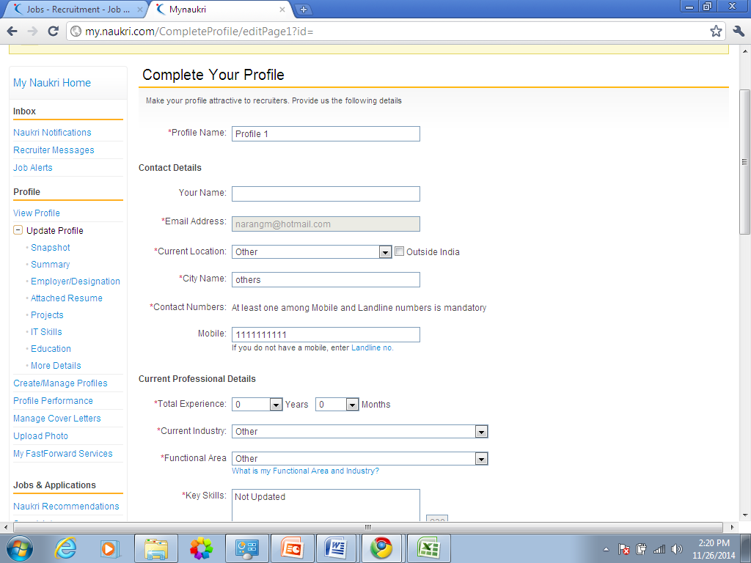

Step 3: Fill the required tabs (mentioned on the left column of the snapshot).
Check for naukri recommendations regularly. In case you applied for any jobs that will appear in application history.

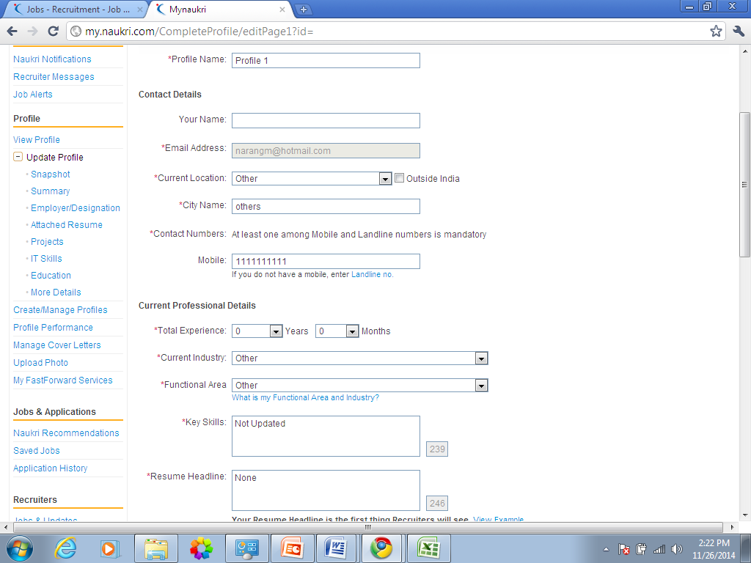

Choose current industry as Hotel/airline/travel

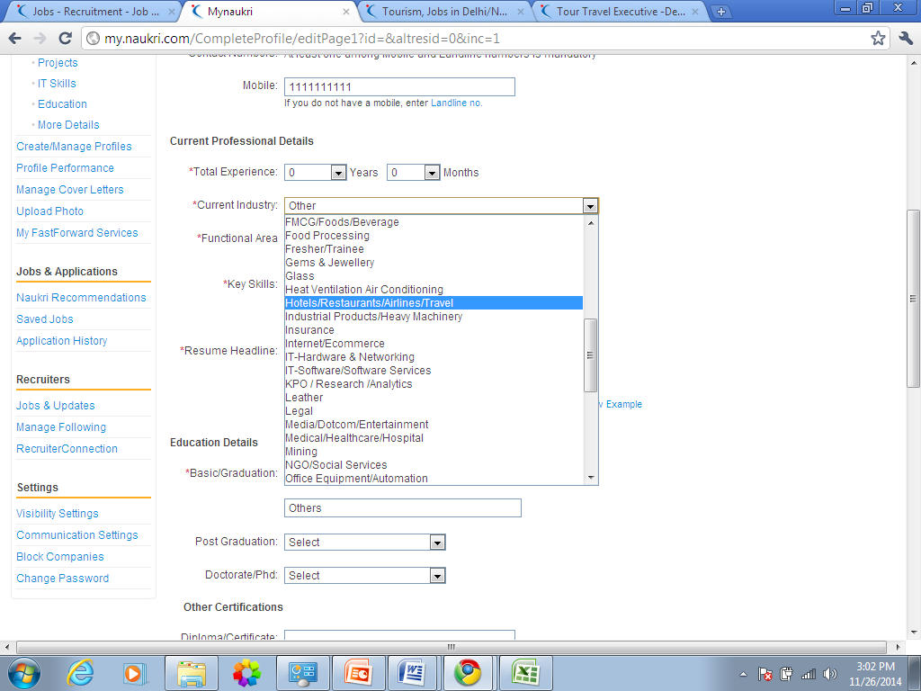
Choose this option for current industry

Choose functional area as ticketing/travel/airlines
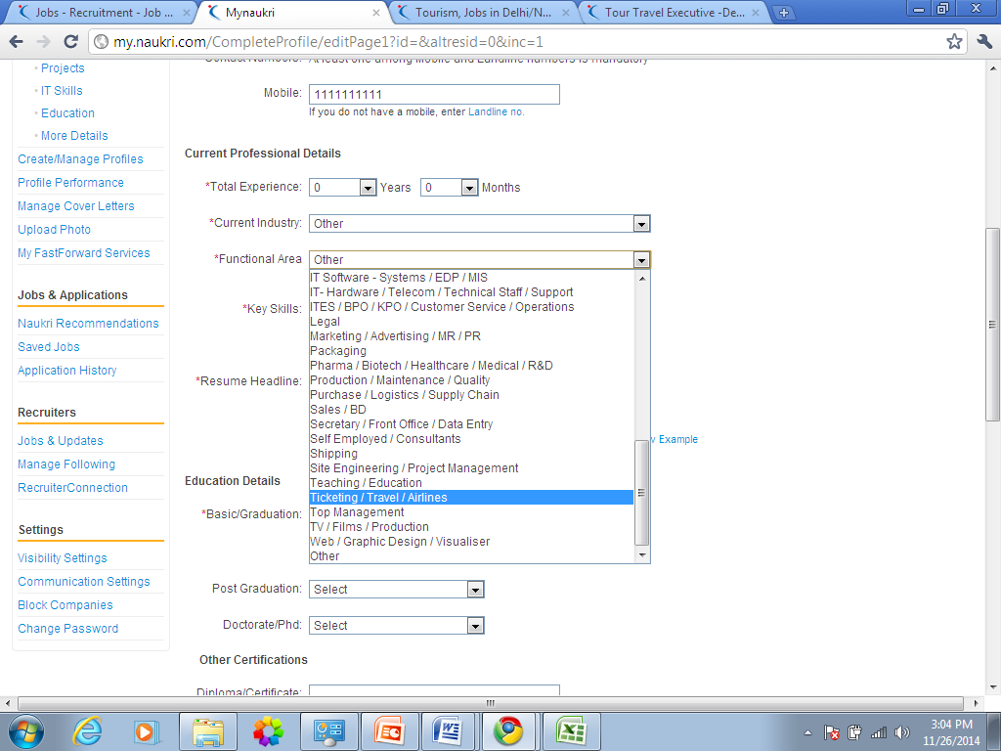
Choose this option for Functional area
Key skills to be mentioned: Air ticketing, destination training ( Dubai, Italy, etc), Itinerary designing, costing, hotel bookings, visa knowledge,etc.
Resume headline: Choose from this:-
1. Expertise in air ticketing and Amadeus
2. Expertise in itinerary designing, costing, air ticketing, destination knowledge etc.
3. Expertise in destination knowledge
4. Competent professional with 3 yrs of experience and having knowledge of itinerary designing, destination and ticketing knowledge.
Education details:
Choose basic graduation as: Diploma
In Diploma/ Certifications: Mention the course name done from Tourism School
Example: 1 Travel and tourism foundation diploma from The Tourism School, 2. Air Ticketing course from The Tourism School

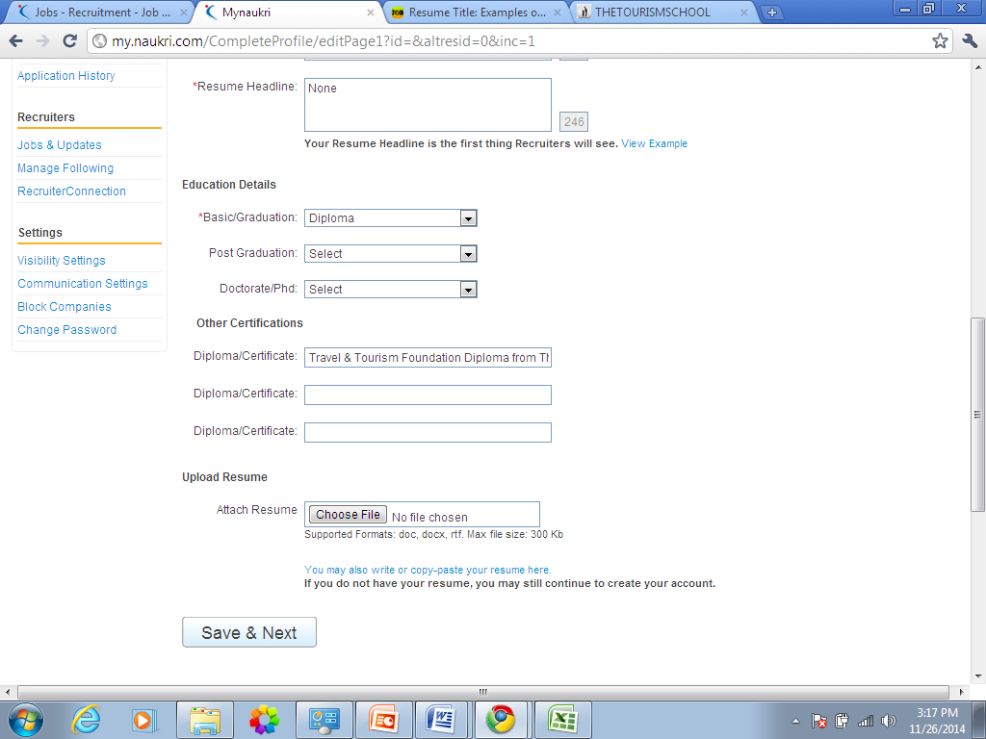
Rest of the details to be filled is basic details like education, contact details, photo upload, etc.
Note :Update your profile every week (may be a small change) as this will make your profile appear on the top in search results of recruiters.


